4/2/2023

Research work 4:

1. Can we use more than one IDE to develop programs for a microcontroller? Describe it.

🡪Yes, we can use more than one IDE to develop programs for a microcontroller. An Integrated Development Environment (IDE) is a software application that provides comprehensive facilities to computer programmers for software development. Different microcontroller manufacturers offer their own IDEs, and many third-party IDEs are also available for different platforms and programming languages. You can use any number of IDEs that you prefer or that suit your project requirements. Can we use more than one IDE to develop programs for a microcontroller? Describe it.

2. Write the name of manufacturer and IDE for following microcontrollers-

2a. Atmega series

AVR was developed in the year 1996 by Atmel Corporation. The architecture of AVR was developed by Alf-Egil Bogen and Vegard Wollan. AVR derives its name from its developers and stands for Alf-Egil Bogen Vegard Wollan RISC microcontroller, also known as Advanced Virtual RISC. The AT90S8515 was the first microcontroller which was based on AVR architecture however the first microcontroller to hit the commercial market was AT90S1200 in the year 1997.

AVR microcontrollers are available in three categories:

1.      TinyAVR – Less memory, small size, suitable only for simpler applications

2.      MegaAVR – These are the most popular ones having good amount of memory (upto 256 KB), higher number of inbuilt peripherals and suitable for moderate to complex applications.

3.      XmegaAVR – Used commercially for complex applications, which require large program memory and high speed.

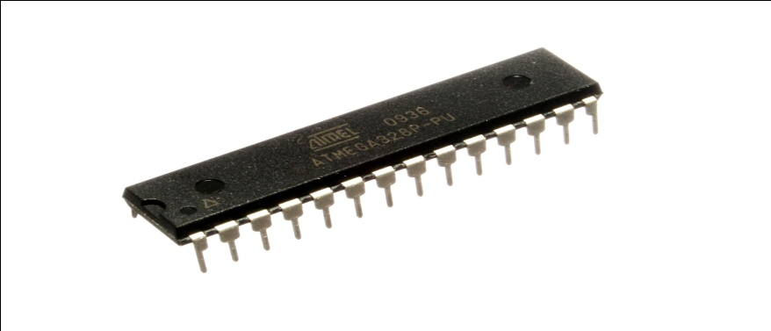

2b. STM32 Series

--->The STM32 is the third ARM family by STMicroelectronics. It follows their earlier STR9 family based on the [ARM9E](https://en.wikipedia.org/wiki/ARM9E) core, and STR7 family based on the [ARM7TDMI](https://en.wikipedia.org/wiki/List_of_ARM_microprocessor_cores) core.

IDE For STM32:

STM32CubeIDE is an all-in-one multi-OS development tool, which is part of the STM32Cube software ecosystem.

STM32CubeIDE is an advanced C/C++ development platform with peripheral configuration, code generation, code compilation, and debug features for STM32 microcontrollers and microprocessors

STM32CubeIDE includes build and stack analyzers that provide the user with useful information about project status and memory requirements.

STM32CubeIDE also includes standard and advanced debugging features including views of CPU core registers, memories, and peripheral registers, as well as live variable watch, Serial Wire Viewer interface, or fault analyzer

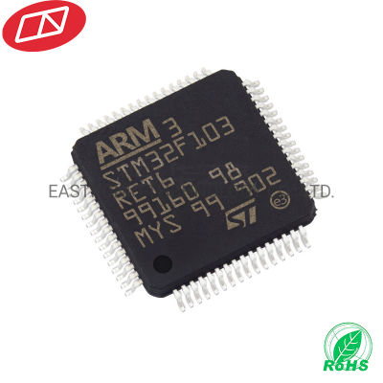

**2c. PIC32 Series**

**PIC** (usually pronounced as *"pick"*) is a family of microcontrollers made by Microchip Technology, derived from the PIC1650originally developed by General Instrument s Microelectronics Division.

In November 2007, Microchip introduced the PIC32MX family of 32-bit microcontrollers, based on the MIPS32 M4K Core The device can be programmed using the Microchip MPLAB C Compiler for PIC32 MCUs a variant of the GCC compiler.

IDE For PIC32:

Piklab is an open source integrated development environment (IDE) for applications devised on Microchip PIC and digital signal processor IC (dsPIC) microcontroller (MCU) that can be compiled only with Qt on Linux and Windows.

MPLAB Integrated Development Environment (IDE) is a FREE, integrated toolset for the development of embedded applications employing Microchip's PIC® and dsPIC® microcontrollers.

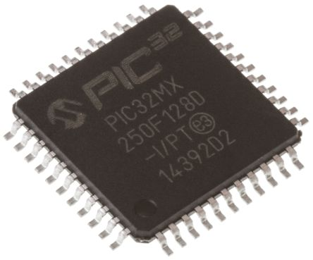

**2d. LPC2000 Series**

**LPC** is a family of 32-bit [microcontroller](https://en.wikipedia.org/wiki/Microcontroller) [integrated circuits](https://en.wikipedia.org/wiki/Integrated_circuit) by [NXP Semiconductors](https://en.wikipedia.org/wiki/NXP_Semiconductors) (formerly Philips Semiconductors). The LPC chips are grouped into related series that are based around the same [32-bit](https://en.wikipedia.org/wiki/32-bit) [ARM](https://en.wikipedia.org/wiki/ARM_architecture) processor core, such as the [Cortex-M4F](https://en.wikipedia.org/wiki/ARM_Cortex-M4F), [Cortex-M3](https://en.wikipedia.org/wiki/ARM_Cortex-M3), [Cortex-M0+](https://en.wikipedia.org/wiki/ARM_Cortex-M0%2B) or [Cortex-M0](https://en.wikipedia.org/wiki/ARM_Cortex-M0)

IDE For LPC2000:

The LPCXpresso IDE is part of NXP’s comprehensive LPCXpresso development platform designed to give developers an easy, low-cost way to create high-quality applications using LPC MCUs. Low-cost LPCXpresso development boards, available for most LPC MCU series, work with the LPCXpresso IDE

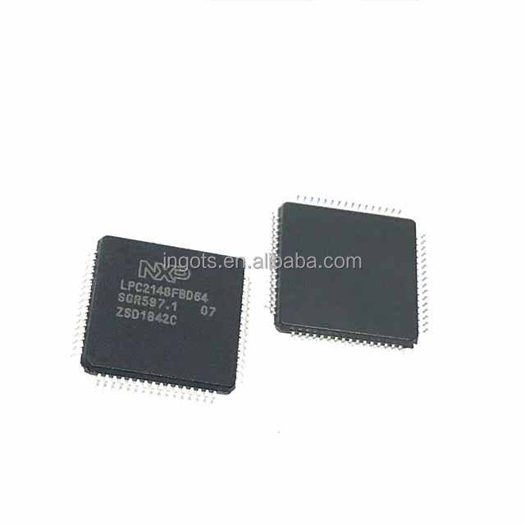

2e. RX210 Series

The RX210 series microcontroller is manufactured by Renesas Electronics Corporation. Renesas is a Japanese semiconductor company that specializes in the design, development, and manufacture of a wide range of microcontrollers, embedded systems, and other products for the automotive, industrial, and consumer markets. The RX210 series microcontrollers are highly integrated, high-performance microcontrollers that are designed for a wide range of applications, including automotive systems, industrial equipment, and consumer electronics

IDE for Rx210 :

The High-performance Embedded Workshop provides a GUI-based integrated development environment for the development and debugging of embedded applications for Renesas microcontrollers.

The High-performance Embedded Workshop, a powerful yet easy to use [**tool suite**](https://www.renesas.com/us/en/software-tool/high-performance-embedded-workshop#toolsuites), features an industry standard user interface and is designed using a modular approach seamlessly incorporating device family-specific C/C++ compilers and the debugger elements for various debugging platforms including emulators and evaluation boards.

1. Why arduino is popular and why still it is not commercially used?

🡪 Arduino is popular for several reasons:

* **User-friendly:** Arduino has a user-friendly platform and a simplified programming language making it easy for beginners to learn and get started with.
* **Open-source**: Arduino is open-source, which means users have access to a vast community of developers who share their knowledge and code. This makes it easy for users to find help and inspiration for their projects.
* **Inexpensive**: Arduino boards and components are relatively inexpensive, making it accessible for hobbyists, students, and small businesses.
* **Versatile:** Arduino can be used for a wide range of applications, including IoT, robotics, home automation, and more.
* **Large community support**: The vast and active community of Arduino developers is a valuable resource for learning and troubleshooting.
* **Easy to integrate with other technologies**: Arduino is compatible with a wide range of sensors, actuators, and other devices, making it easy to integrate with other technologies and systems.

These features make Arduino a popular choice for hobbyists, makers, students, and small businesses, as well as a valuable tool for learning and prototyping new ideas.

* **Arduino is professionally used in education, entertainment, manufacturing, 3D printing, and live entertainment. They can even serve industrial purposes, though it’s not common. Arduino is most commonly used by engineers as a prototyping tool to help them physically visualize their design. This lets them add improvements before creating their final product to manufacture.**
* **Limited processing power**: Arduino boards are limited in terms of processing power and memory, which can be a disadvantage for complex commercial projects that require more processing power.
* **Fragile hardware**: Arduino boards and components can be fragile, which can be a disadvantage for commercial projects that require durability and reliability.
* **Security concerns**: The open-source nature of Arduino can lead to security concerns for commercial applications, as the code and hardware design are publicly available.
* **Professional development tools**: Commercial projects often require more advanced development tools, such as debugging and testing tools, which are not as readily available for Arduino.
* **In commercial projects**, other microcontroller platforms, such as Raspberry Pi, may be a more suitable choice due to their more advanced capabilities and better performance. However, Arduino still has its place in hobbyist, educational, and prototyping projects, where its ease of use, low cost, and large community support are valuable advantages.
* **It’s a small development board**
* **Arduino cannot last very long**
* **Arduino can’t adapt to the harsh environment (think humidity, temperature, and dust)**

4.List out advantages and disadvantages of Arduino.

🡪 Advantages of Arduino:

1. **Easy to use:** Arduino has a user-friendly platform and a simplified programming language making it easy for beginners to learn and get started with.
2. **Open-source:** Arduino is open-source, which means users have access to a vast community of developers who share their knowledge and code.
3. which also means that users have access to the source code and can modify it to suit their needs.
4. **Inexpensive:** Arduino boards and components are relatively inexpensive, making it accessible for hobbyists, students, and small businesses.
5. **Cross-platform compatibility**: Arduino software can run on multiple operating systems, including Windows, MacOS, and Linux.
6. **Large community support**: The vast and active community of Arduino developers is a valuable resource for learning and troubleshooting.

Disadvantages of Arduino:

1. **Limited processing power:** Arduino boards are limited in terms of processing power and memory, which can be a disadvantage for complex projects.
2. **Lack of built-in peripherals :**Arduino does not typically support peripherals out of the box. This means that unless programmed to do so, Arduino doesn’t have real support for:
3. Keyboard
4. Mouse
5. Display
6. **Lack of real-time control:** Arduino boards do not have real-time control capabilities, which can be an issue for certain applications that require real-time responses.
7. **Fragile hardware**: Arduino boards and components can be fragile, which can be a disadvantage for projects that require durability.
8. **Lack of Multitasking**: Arduino boards are limited to run only a single program at a time. Other competitor boards like Raspberry Pi offers multitasking functionality. Like multicore CPUs that can run multiple programs without slowing the speed of the overall system, Arduino lacks this ability and we must close one sketch to execute the other one.
9. **Less Memory Storage Capacity:** One of the main features which Arduino lacks is it has limited memory storage. Arduino UNO has 2kb of SRAM and 32kb of flash memory which can only store sketches with hundreds of lines. Due to this Arduino has limited scope in the robotics world and cannot be used in industrial scale projects.
10. Does Arduino uses c/c++ ? Describe it.

🡪

Arduino uses a variant of C++ as its primary programming language, not C. The Arduino Integrated Development Environment (IDE) supports the programming of Arduino boards using a simplified version of C++, which makes it easier for beginners to get started with electronics and programming. The Arduino language is based on C++, but it has some differences and extensions that make it more accessible to those who are new to programming

IDE compiles our C++ code into assembly language which is used by Atmel chips mounted over Arduino boards also known as **Microcontroller.**

However, it's possible to write code for the Arduino platform using C, as the underlying microcontroller runs a C-based firmware. Many Arduino libraries are written in C, and the Arduino IDE supports both C and C++. Some advanced users may prefer to write their Arduino programs in C for more control over the microcontroller and for compatibility with other C-based systems.

In summary, while Arduino uses C++ as its primary programming language, it's possible to write code for the platform using C as well